Word2Vec is a technique used in Natural Language Processing (NLP) to convert words into numerical vectors (embeddings) so that machines can understand their meanings.

The Core Problem
Before Tomas Mikolov introduced Word2Vec at Google, words were represented as:
👉 One-hot vectors
Example:
King = [0,0,0,1,0,0]
Queen = [0,0,1,0,0,0]
Problem?
- No meaning
- No similarity
- No relationship
Why bad?
Because ML models think in numbers and distance.
We needed words placed in a meaningful space.

🔥 The Big Idea Behind Word2Vec
Words that appear in similar contexts have similar meanings.
This is called:
Distributional Hypothesis
Example:
Sentence 1: “The cat is drinking milk.”
Sentence 2: “The dog is drinking milk.”
If “cat” and “dog” appear in similar environments,
they must be related.

🧠 Analogy: Friend Circle Theory
Imagine college groups.
If:
- Aman hangs out with Ravi, Simran, Karan
- Arjun also hangs out with Ravi, Simran, Karan
You assume:
Aman ≈ Arjun (similar personality group)
Word2Vec does the same.
It says:
“Tell me your neighbors, I’ll tell you who you are.”

How It Actually Learns (Skip-gram Model)
There are 2 types:
- CBOW
- Skip-gram
Let’s focus on Skip-gram.
If sentence is:
“The cat sits on the mat”
And center word = "cat"
Model tries to predict:
- The
- Sits
So training data becomes:
Input: cat → Output: The
Input: cat → Output: sits
Why do this?
Because to correctly predict neighbors,
the model must understand the word’s role.

But HOW Does Meaning Emerge?
Here is the deep part your tutor wanted:
When the neural network adjusts weights to predict neighbors,
it learns:
- Similar words require similar weight patterns
- Those weights become embeddings
So embeddings are:
👉 Compressed behavioral summaries of words.
They are not meaning.
They are mathematical patterns that reflect usage.

🧮 Why King – Man + Woman ≈ Queen Works?
Because:
King appears near:
- Royal
- Palace
- Man
Queen appears near:
- Royal
- Palace
- Woman
The network encodes:
- Gender direction
- Royalty direction
Vector arithmetic works because:
The model organizes semantic relationships as directions.
This is NOT magic.
It’s geometry emerging from prediction.

Why Not Just Use Frequency?
If frequency was enough:
- “the” would be most meaningful word.
But frequency ≠ meaning.
Word2Vec captures:
- Context similarity
- Not count similarity

Why Word2Vec Changed NLP
Before:
Manual feature engineering.
After:
Dense vectors learned automatically.
This shift enabled:
- Google Search improvements
- Modern embeddings
- Later models like OpenAI's embeddings
- Even foundations of OpenAI GPT systems
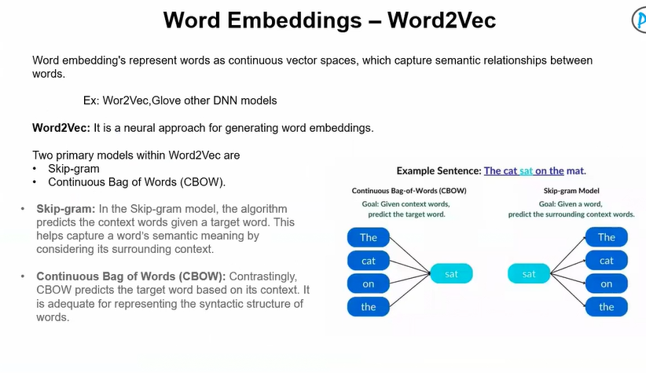

GloVe (Global Vectors)
Developed by researchers at Stanford University.

What Problem Does It Solve?
Problem with Word2Vec:
- It learns embeddings using local context windows
- It is prediction-based (neural network)
- It doesn’t explicitly use full corpus statistics
GloVe tries to:
Use global co-occurrence statistics of the entire corpus to build word vectors.
In simple terms:
Instead of predicting neighbors,
it asks:
“How often do words appear together in the whole dataset?”

2. Why Was Previous Method (Word2Vec) Limited?
Word2Vec (by Tomas Mikolov at Google):
- Uses sliding window
- Learns via prediction
- Doesn’t directly encode global co-occurrence ratios
Example problem:
Word2Vec doesn’t explicitly model:
Probability(ice | solid)
Probability(ice | gas)
But ratios like these contain meaning.
Researchers noticed:
Ratios of co-occurrence probabilities capture semantic relationships better.

Core Assumption of GloVe
Here is the deep idea:
The ratio of co-occurrence probabilities between words encodes meaning.
Example intuition:
Consider word “ice” and “steam”.
- Ice co-occurs more with “solid”
- Steam co-occurs more with “gas”
So the ratio:
P(solid | ice) / P(solid | steam)
Will be high.
That ratio captures semantic difference.
GloVe assumes:
These ratios should be encoded in vector space.

How Does Math Enforce That Idea?
Now the important engineering part.
Let:
Xᵢⱼ = number of times word j appears in context of word i
(Co-occurrence matrix)
They want:
Dot product of word vectors to approximate:
log(Xᵢⱼ)
So objective function becomes:
Minimize:
(wᵢ · wⱼ + bᵢ + bⱼ − log Xᵢⱼ)²
Why log?
Because:
- Raw counts vary massively
- Log smooths distribution
- Makes optimization stable
So mathematically:
If two words co-occur frequently,
their dot product becomes large.
If rarely,
dot product becomes small.
So geometry encodes statistics.
This is not prediction-based.
It is matrix factorization of log co-occurrence matrix.
That’s the core.

🧠 Why This Is Powerful
Word2Vec:
Learns from predicting neighbors.
GloVe:
Learns from directly factorizing global statistics.
So:
Word2Vec = Local predictive model
GloVe = Global count-based model
But interestingly…
They often produce similar embeddings.

Where Does GloVe Fail?
Very important.
❌ Still produces static embeddings
→ “bank” problem still exists
❌ Needs large co-occurrence matrix
→ Memory heavy
❌ Rare words poorly represented
❌ Cannot handle dynamic meaning shift in sentence
That’s why contextual models later replaced them.

🎯 Deep Comparison Summary
Aspect | Word2Vec | GloVe
Type | Predictive | Count-based
Context | Local window | Global corpus
Objective | Predict neighbors | Factorize log co-occurrence
Embedding type | Static | Static
Polysemy | Problem | Still problem

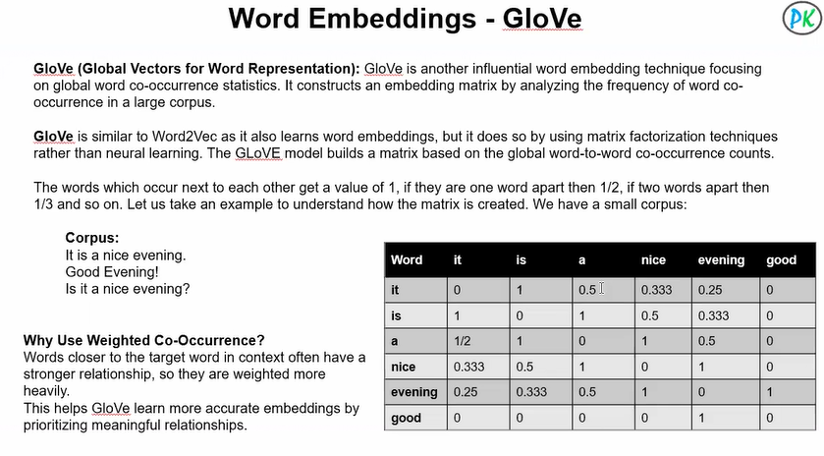
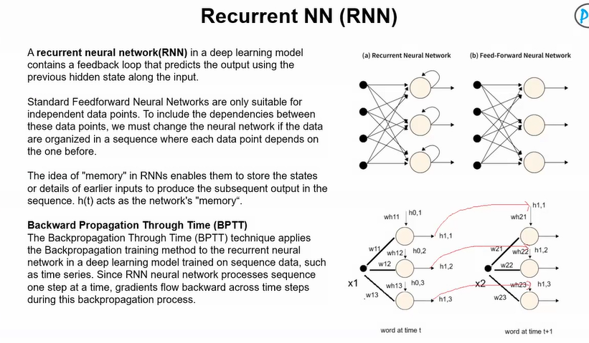

Recurrent Neural Networks (RNN)

1 What Problem Does RNN Solve?
Problem:
Traditional feedforward neural networks assume:
Each input is independent.
But language is sequential.
Example:
“I grew up in France. I speak fluent ___.”
To predict “French”, the model must remember “France”.
So the real problem is:
👉 How do we model sequence dependency over time?
Feedforward networks cannot remember past inputs.
RNN introduces memory.

2Why Was Previous Method Bad?
Feedforward networks:
- Process fixed-size input
- No notion of time
- No memory of previous state
If you input words one by one,
the model forgets previous words completely.
It treats:
“The dog barked”
and
“Barked the dog”
as unrelated patterns unless explicitly engineered.
So:
❌ No temporal structure
❌ No sequential modeling
❌ No parameter sharing over time
RNN fixes this.

3.Core Assumption of RNN
The core idea:
The current state of a sequence depends on the previous state.
Mathematically:
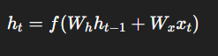Meaning:
Hidden state at time t depends on:
- Previous hidden state
- Current input
This creates a chain of memory.
Assumption:
Past information can be compressed into a fixed-size hidden vector.
That’s powerful… and also its weakness.

4 How Does Math Enforce That Idea?
Let’s go step-by-step.
Hidden state update:
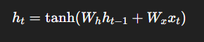Notice:
- Same weight matrices at every time step
- Parameters shared across time
This enforces:
Temporal consistency.
Now during Backpropagation Through Time (BPTT):
Loss at final step affects earlier hidden states.
Gradients flow backward through time:
So earlier states get updated based on future errors.
That’s how the model learns long-term patterns.
Memory is enforced by recurrence + shared weights.

RNN is like:
A rolling summary of everything seen so far.
Each hidden state compresses history into a vector.
So instead of storing full sentence,
it stores a compressed representation.
That compression is learned.

Where Does RNN Fail?
Now the real engineering reality.
❌ Vanishing Gradient Problem
When backpropagating many time steps,
gradients shrink exponentially.
So early words stop influencing learning.
Example:
In long paragraph,
RNN forgets beginning.
❌ Exploding Gradient
Gradients can also blow up.
❌ Fixed-size memory bottleneck
Entire past compressed into single vector.
❌ Slow (sequential computation)
Cannot parallelize across time steps.
These limitations led to:
- LSTM
- GRU
- Eventually Transformers

LSTM (Long Short-Term Memory)
Introduced by Sepp Hochreiter and Jürgen Schmidhuber in 1997.

What Problem Does LSTM Solve?
Problem in RNN:
- Vanishing gradients
- Cannot remember long-range dependencies
- Early information gets washed out
Example:
“I grew up in France … after many years … I speak fluent ___.”
RNN forgets “France.”
LSTM solves:
👉 Long-term dependency problem.

2. Why Was RNN Bad?
RNN update:
During backpropagation:
Gradients multiply repeatedly by W_h.
If eigenvalues < 1 → gradient shrinks exponentially.
If > 1 → explodes.
So:
❌ Information decays over time
❌ Long-term learning unstable
RNN has no control over what to remember or forget.
Everything passes through tanh blindly.

3. Core Assumption of LSTM
LSTM assumes:
Memory should have a controlled pathway where gradients can flow unchanged.
Instead of one hidden state,
LSTM introduces:
- Cell state (long-term memory)
- Hidden state (short-term output)
Key idea:
Memory should be modified additively, not multiplicatively.
This prevents gradient vanishing.

4. How Does Math Enforce That Idea?
Now the engineering beauty.
LSTM introduces gates.

Intuition
RNN:
Memory is like water in sponge — leaks quickly.
LSTM:
Memory is like pipeline with valves.
You control:
- What to forget
- What to add
- What to expose

Where Does LSTM Fail?
Even LSTM has limits.
❌ Still sequential (cannot parallelize well)
❌ Hard to train on very long documents
❌ Memory still fixed-size vector
❌ Computationally heavy (many gates)
This led to:
Transformers.

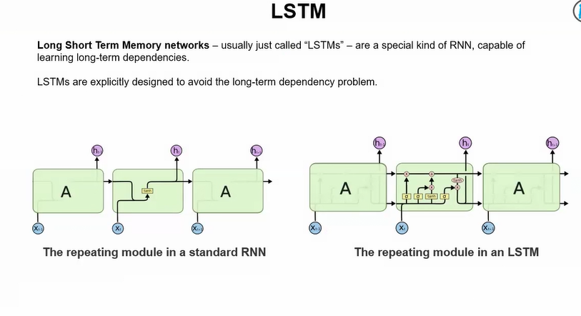
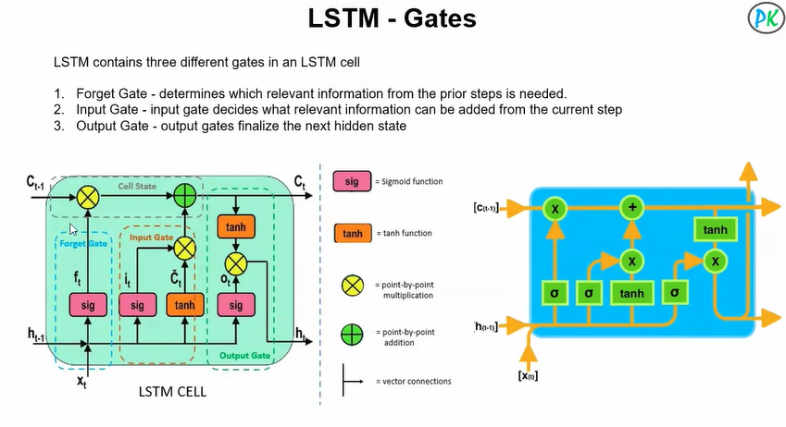

What is Prompt Engineering?
Prompt Engineering is the skill of designing effective inputs (prompts) to guide a GenAI model to produce better outputs.
A prompt = the instruction you give to the AI.
Since GenAI models respond based on patterns learned from data, the quality of output heavily depends on how you ask the question.

